Homework:

1. For each of the following pairs of variables, indicate whether you would expect a positive correlation, a negative correlation, or a correlation close to 0. Explain your choice.  
   a. Maximum daily temperature and cooling costs  
   b. Interest rate and number of loan applications  
   c. Height and IQ
2. Data from the U.S. Federal Reserve Board (Household Debt Service Burden, 2002) on the percentage of disposable personal income required to meet consumer loan payments and mortgage payments for selected years are shown in the following table:

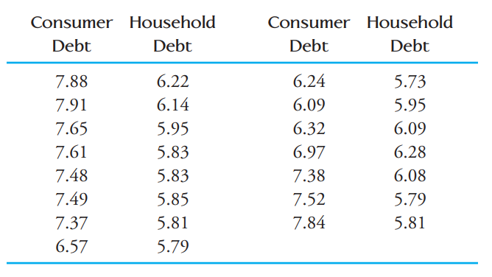

a. What is the value of the correlation coefficient for this data set?  
b. Is it reasonable to conclude in this case that there is no strong relationship between the variables (linear or otherwise)? Use a graphical display to support your answer.

1. Try to draw dots and observe the results given by the website. http://digitalfirst.bfwpub.com/stats_applet/stats_applet_5_correg.html